Sri Lanka Institute of Information

Technology



Lab Submission

<Lab sheet No 06>

**<IT24101556>**

**<Bamunusinghe BAIBT>**

**Probability And Statistics | IT2120**

B.Sc. (Hons) in Information Technology

**Exercise**

Q1) 1.

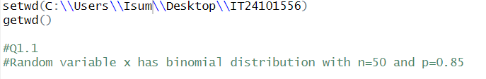



2.

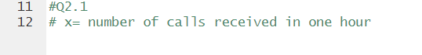Q2) 1.

2. 

3.

